Experiment No: 01
Experiment Name:
i) Write an assembly language program for simple input and output using EMU8086
ii) Write an assembly language program for simple input and output, where the output is displayed on a new line using EMU8086

Theory: EMU8086 assembly provides low-level control of the 8086 microprocessor using DOS interrupts. In EMU8086, set AH to 1 and call INT 21H for input. The ASCII value stores in AL and then moves to BL. Set AH to 2 and load DL to print any character. Output ASCII 10 and 13 for a new line. Use AH = 4CH with INT 21H to exit and return control.

Code & Output:
i) Code for simple input and output:
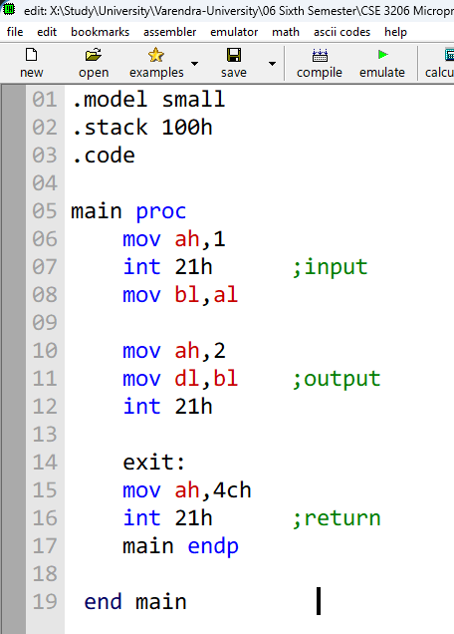

B4 01 CD 21 FF FF CF 8A D8 B4 02 8A D3 CD 21 FF FF CF B4 4C CD 21 FF FF
Machine Code:

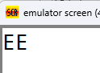
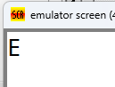
Output:
Output
Input

ii) Code for simple input and output, where the output is displayed on a new line:
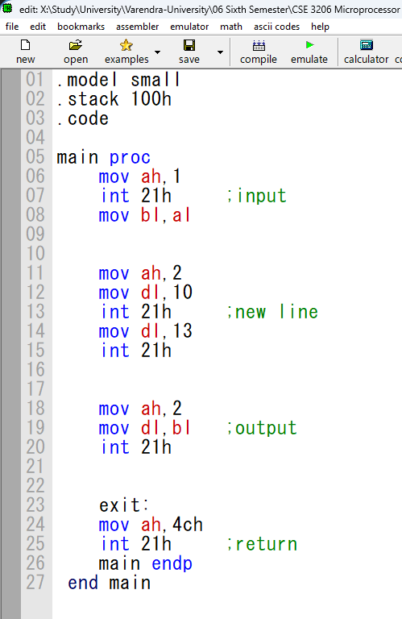

B4 01 CD 21 FF FF CF 8A D8 B4 02 B2 0A CD 21 FF FF CF B2 0D CD 21 FF FF CF B4 02 8A D3 CD 21 FF FF CF B4 4C CD 21 FF FF CF
Machine Code:

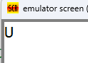
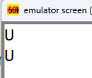
Output:
Input
Output

Conclusion:
The program was executed successfully in the EMU8086 environment, and no errors were found. We successfully learned two basic concepts of EMU8086: simple input and output & simple input and output in new line.

